

Imam Abdulrahman Bin Faisal University College of Computer Science & Information Technology Department of Computer Science BCS 202– Software Engineering Term 2 – 2025/2026

Software Test Plan

For

Mizan

[-]

Version: (3.0) Date: (05/17/2026)

Revision History

Name | Date | Reason For Changes | Version
Mishal Al-jumaih | 2026-05-08 | Initial draft of the document. | 0.1
Mishal Al-jumaih | 2026-05-09 | Completed sections 1, 2, and 10. | 0.2
- | 2026-05-10 | Completed sections 3, 4, and 8. | 0.3
- | 2026-05-10 | Completed section 5. | 0.4
Mishal Al-jumaih | 2026-05-11 | Added section 7, standardized document fonts, and integrated structural diagrams. | 1.0
Mishal Al-jumaih | 2026-05-12 | Added remaining UML and testing diagrams. | 1.1
- | 2026-05-13 | Integrated test evidence and UI screenshots. | 2.0
- | 2026-05-14 | Reviewed document structure and aligned it with the IEEE Software Test Plan template. | 2.1
Mishal Al-jumaih | 2026-05-15 | Finalized all testing screenshots and completed pending schedule tasks. | 2.2
Mishal Al-jumaih | 2026-05-16 | Final review and formatting of the Test Plan for submission. | 3.0

Table of Contents
Revision History i
Table of Contents ii
Table of Tables iv
Table of Figures v
1. Introduction 1
1.1 Objectives 1
1.2 Testing Strategy 1
1.3 Scope 2
2. Test Items 5
2.1 Program Modules 6
2.2 PHP Application Modules 6
2.3 Job Control Procedures 8
2.4 User Procedures 8
2.5 Operator Procedures 9
3. FEATURES TO BE TESTED 10
4.FEATURES NOT TO BE TESTED 12
5. Approach 13
5.1 Component Testing 13
5.2 Integration Testing 17
5.3 Conversion Testing 19
5.4 Job Stream Testing 19
5.5 Interface Testing 20
5.6 Security Testing 22
5.7 Recovery Testing 24
5.8 Performance Testing 25
1. 5.9 Regression Testing 27
5.10 Acceptance Testing 28
5.11 Beta Testing 28
6. Pass / Fail Criteria 30
6.1 Suspension Criteria 31
6.2 Resumption Criteria 31
6.3 Approval Criteria 32
7. Testing Process 33
7.1 Test Deliverables 33
7.2 Testing Tasks 33
7.3 Responsibilities 34
7.4 Resources 35
7.5 Schedule 35
8.Environmental Requirements 36
8.1 Hardware 36
8.2 Software 36
8.3 Security 36
8.4 Tools 36
8.5 Publications 36
8.6 Risks and Assumptions 37
9. Change Management Procedures 38
10. Test Approvals 39

Table of Tables
Table 1PHP Application Modules 6
Table 2 FEATURES TO BE TESTED 10
Table 3: FEATURES NOT TO BE TESTED 12
Table 4PASS / FAIL Table 30
Table 5:Testing Tasks 33
Table 6:Schedule 35

Table of Figures

Figure 1:Diagram A: PY_TestingPyramid 1
Figure 2Component Diagram: MVC Architecture (Section 2.1) 5
Figure 3State Machine: Language & Theme Toggle (T-14 & T-15) 9
Figure 4 DIAGRAM B: TB_TestCoverage 11
Figure 5:T-01 User Registration (bcrypt hash, email uniqueness) 14
Figure 6:T-02-FR-01-User Login — valid credentials, session creation Functional 15
Figure 7:T-08-FR-06-File Upload — Vault (max 500 MB, MIME validation via finfo)Functional, Security 16
Figure 8:Component Testing (5.1) 17
Figure 9:T-07-FR-05-Record Expense — DECIMAL(12,2) precision, category & vendor Functional, Data Integrity 18
Figure 10Integration Testing (5.2) 18
Figure 11:Figure Job Stream Testing (5.4) 20
Figure 12Interface Testing (5.5) 21
Figure 13:T-15-FR-13Dark/Light Theme — CSS custom properties, no page reload (FOUC-free)Functional, UI 22
Figure 14:T-11 FR-09 Visual Reports — Chart.js bar, doughnut, P&L line chart Functional, UI 22
Figure 15:T-18-NFR-02SQL Injection Prevention — PDO prepared statements, 100% coverage Security 23
Figure :16T-03-FR-01 Brute-Force Protection — login_attempts rate limiter Security 24
Figure 17: Security Testing (5.6) 24
Figure 18: Recovery Testing (5.7) 25
Figure 19: Performance Testing (5.8) 26
Figure 20:T-24-NFR-0860 FPS Performance Budget — rafThrottle / requestAnimationFrame enforcement Performance 27
Figure 21: Regression Testing (5.9) 28
Figure 22Acceptance & Beta Testing (5.10&11) 30
Figure 23 DIAGRAM C: TB_DefectSeverity 32
Figure 24 DIAGRAM D: TB_RACI 34
Figure 25 DIAGRAM F: TB_RiskMatrix 37
Figure 26 DIAGRAM G: FC_ChangeManagement 39

Introduction

1.1 Objectives
the software test plan for the Mizan system is intended to accomplish the following goals:
- Describe the extent, approach, resources, and schedules for testing activities for the Mizan system.
- Determine which software items and their functionalities should be tested, while listing those which will not be subject to testing.
- List the deliverables, tasks, assignments, and risk handling measures for testing activities.
- Serve as a standardized reference for everyone concerning the testing approach.
- Check whether the system being implemented complies with the functional requirements (FR-01 to FR-14) and non-functional requirements (NFR-01 to NFR-08) stated in the Mizan SRS v2.0.

1.2 Testing Strategy
For the testing approach employed on the Mizan system, "Bottom-Up" integration testing approach is employed along with the Agile methodology approach of continuous testing. This approach is broken down into three major stages aimed at covering the MVC approach and user experience.
1. Development & Component Testing (White-Box)
- Objective: Verify the internal logic of individual software components before integration.
- Testing: Conducted continuously by the developers during the coding phase. This includes testing individual PHP API endpoints (api/*.php), validating PDO prepared statements for database queries, and verifying the rafThrottle logic within the main.js engine.
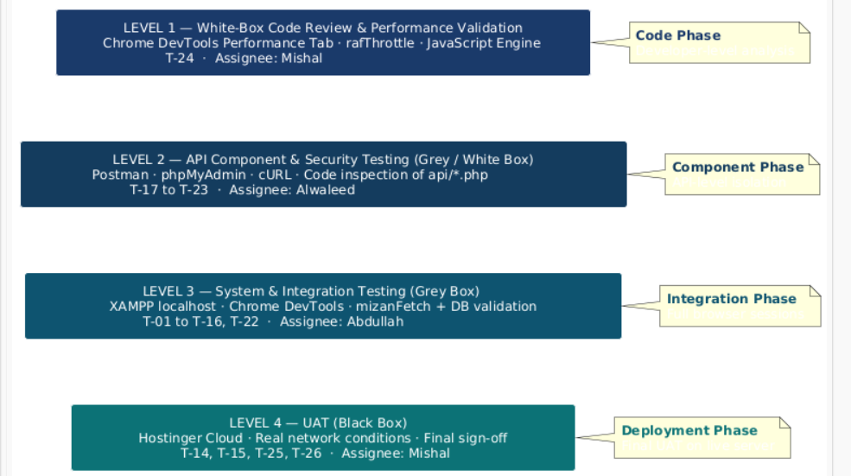
Figure 1:Diagram A: PY_TestingPyramid
2. System and Integration Testing (Grey-Box and Black-Box)
Objective: To test whether the integration between the modules such as the Frontend UI, Backend API, and MySQL Database is done according to the functionality and security requirements described in the SRS v2.0.
Testing: Done in the local XAMPP environment. In this stage, there are both Grey-Box testing where there will be a check for API calls using Chrome DevTool Network tab and Database operations through phpMyAdmin along with Black-Box testing.
3. User Acceptance Testing (UAT) (Deployment)
Objective: Verify that the system behaves as expected in a live environment, meeting the requirements and conditions of acceptance of the system by the end user.
Testing: The Potentially Shippable Product Increment (PSPI) will be deployed to a live environment on Hostinger/Cpanel. Testing will cover configuration of the server (.htaccess routing, SMTP mail setup), as well as responsiveness on various devices.

1.3 Scope
This test plan describes testing of all Mizan web application at system level and integration level. The test plan will include Primary System Testing performed locally on the XAMPP platform (Apache + MySQL 8.x), and User Acceptance Testing (UAT) conducted on the live cloud-based deployment. The tests will include:
- All fourteen functional requirements (FR-01 to FR-14) described in Mizan SRS v2.0.
- All eight non-functional requirements (NFR-01 to NFR-08) described in Mizan SDS v2.0.
- All fourteen subsystems defined in Mizan SDS v2.0 in Section 5.3.
- Security testing for various attack vectors such as CSRF, XSS, SQL injection, brute-force, and MIME Spoofing.
- Performance testing for 60 FPS rendering objective, rafThrottle performance and notifications polling.
- Web Accessibility testing for WCAG 2.1 AA compliance.
- Bidirectional localization (from Arabic RTL to English LTR and vice versa).
- This test plan DOES NOT include unit testing of PHP functions (to be performed separately per developer) and load stress testing of Mizan (as it is intended for academic purposes only).
1.4 Reference Material
- Mizan SRS v2.0 (26/04/2026) — Software Requirements Specification.
- Mizan SDS v2.0 (10/05/2026) — Software Design Specifications.
- Mizan SPMP v2.0 (18/03/2026) — Software Project Management Plan.
- Mizan Status Report 1 & 2 — BCS 202 Term 2, 2025/2026.
- BCS 202 Project Proposal — Imam Abdulrahman Bin Faisal University.
- IEEE Std 829-1998 — IEEE Standard for Software Test Documentation.
- W3C WCAG 2.1 — Web Content Accessibility Guidelines, Level AA.
- PHP 8.x Documentation — https://www.php.net/docs.php
- MySQL 8.x Reference Manual — https://dev.mysql.com/doc/
- OWASP Testing Guide v4.2 — https://owasp.org/www-project-web-security-testing-guide/
1.5Definitions and Acronyms
This section defines the technical terms, testing terminologies, and acronyms used throughout this Software Test Plan to ensure a clear and unambiguous interpretation by all stakeholders and academic evaluators.
Acronyms:
- API: Application Programming Interface.
- CRUD: Create, Read, Update, and Delete (the four basic functions of persistent storage).
- CSRF: Cross-Site Request Forgery (a web security vulnerability).
- CSPRNG: Cryptographically Secure Pseudorandom Number Generator (used for token generation).
- MVC: Model-View-Controller (the architectural pattern used in Mizan).
- PSPI: Potentially Shippable Product Increment (the final tested outcome of an Agile Sprint).
- QA: Quality Assurance.
- RBAC: Role-Based Access Control (used in the Admin module).
- RTL / LTR: Right-to-Left (Arabic) / Left-to-Right (English) layout direction.
- SDS: Software Design Specification.
- SoC: Separation of Concerns (design principle separating backend API from frontend UI).
- SPMP: Software Project Management Plan.
- SQLi: SQL Injection (a code injection technique that might destroy a database).
- SRS: Software Requirements Specification.
- STP: Software Test Plan (this current document).
- UAT: User Acceptance Testing.
- WCAG: Web Content Accessibility Guidelines.
- XSS: Cross-Site Scripting (a vulnerability where malicious scripts are injected into web pages).
Definitions:
- Black-Box Testing: A method of software testing that examines the functionality of an application without peering into its internal structures or workings (e.g., testing the UI language toggle).
- White-Box Testing: A software testing method in which the internal structure, design, and coding of the item being tested are known to the tester (e.g., verifying rafThrottle in the JavaScript engine).
- Regression Testing: Re-running functional and non-functional tests to ensure that previously developed and tested software still performs after a defect has been fixed.
- Smoke Testing: A preliminary set of tests run to verify that the most critical functions of a program work, used to decide if a build is stable enough to proceed with further testing.
- The Vault: The secure, long-term digital archiving module within the Mizan system designed for storing user invoices, contracts, and warranty files.
- rafThrottle: A JavaScript performance optimization technique using requestAnimationFrame to limit the execution rate of visual updates, ensuring a stable 60 FPS.
- Test Case: A set of conditions or variables under which a tester will determine whether a system under test satisfies requirements or works correctly.
- Incident Report: A formal document detailing a defect or bug discovered during testing, including its severity and steps to reproduce.

Test Items
All software modules that make up the Mizan system will undergo testing. The version of the items to test will match the latest commit from the project root directory. The database used for testing will be the mizan_db as seen in database.sql.

The below documents provide the foundation on which the correct system behavior is determined, and they form the basis of this section:

Requirement specification: Mizan SRS v2.0 (Functional and non-functional requirements).

Design specification: Mizan SDS v2.0 (MVC component design, API, and database schema with additional support/admin tables added to the initial 14 tables).

User and operation guide: README.md project file and inline documentation within the system.
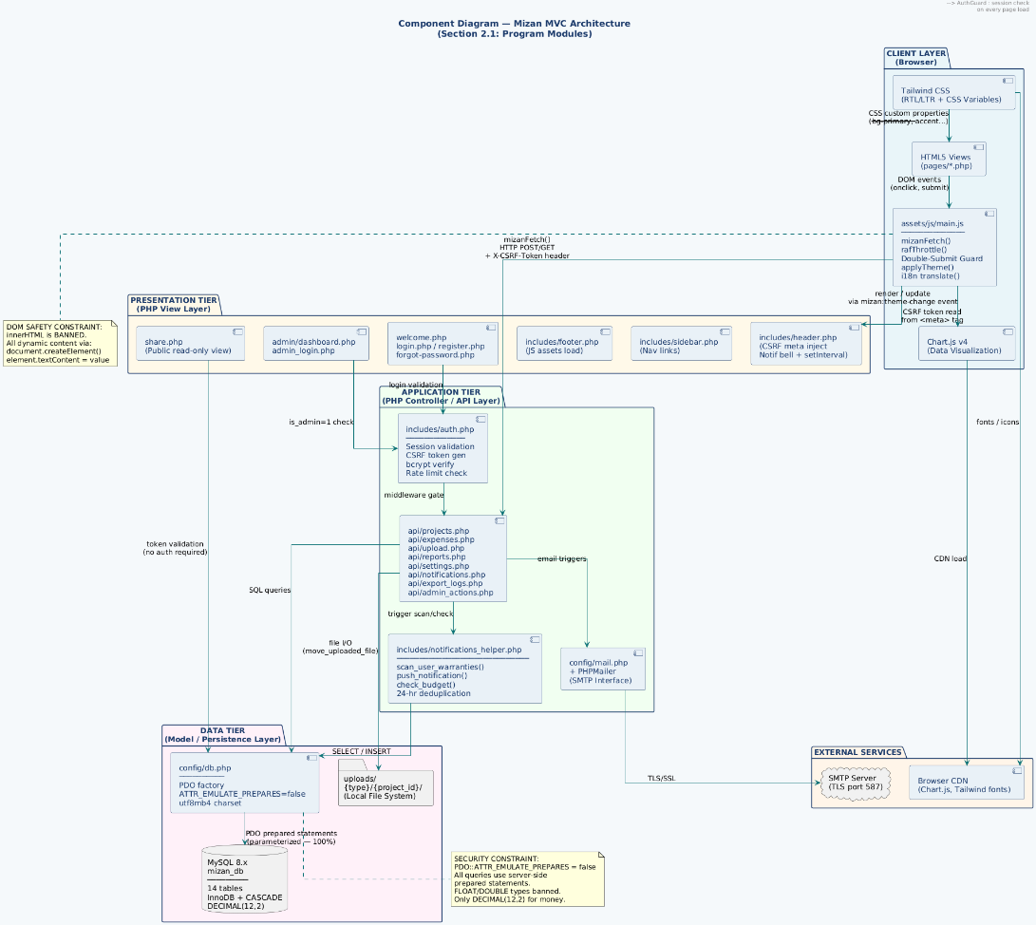
Figure 2Component Diagram: MVC Architecture (Section 2.1)

2.1 Program Modules
- Authentication and Security Module: (login.php, register.php, includes/auth.php). The module will be tested for sessions management, password hashing with bcrypt and CSRF token management.
- Project and Expense Management: (api/projects.php, api/expenses.php, pages/projects.php). This module will be tested for full CRUD operations with strict handling of currency values DECIMAL(12,2), project expense ownership validation.
- The Vault (File Management): (api/upload.php, pages/files.php). This module will be tested for 500 MB file size limitation, thorough MIME validation with finfo and folder separation for invoices and warranty documents.
- Notifications & Warranty Tracking: (api/notifications.php, includes/notifications_helper.php). Will be tested for the notifications deduplication period of 24 hours, automated checking for notification expiration and real time poll request validity.
- Reporting and exporting data: (api/reports.php, api/export_zip.php). This module will be tested for reporting data consolidation with Chart.js functionality, as well as correctness of PDF/CSV and ZIP file generation.
- Admin and Support Module: (admin_login.php, api/admin_actions.php). Tests will include the validation of the role-based access control for administrators with restriction of access to admin endpoints for standard users.
- JavaScript engine: (assets/js/main.js). This module will be tested for DOM safety with usage of textContent, rafThrottle for performance and double submit protection of forms. (Note for the development team: Add Component Diagram here showing the MVC data flow through API, UI pages and MySQL).

2.2 PHP Application Modules
Table 1PHP Application Modules
Module | Source Files | Description
Authentication | login.php, register.php, logout.php, forgot-password.php, reset-password.php | Registration, login, session handling, CSRF handling, and email password reset using SMTP.
Auth Guard | includes/auth.php | Generic session authentication, CSRF token creation, and redirection to unauthorized page.
Dashboard | index.php, views/home.php | Dynamic metrics collection, data retrieval, and UI rendering of dashboard page.
Projects | pages/projects.php, pages/project-detail.php, api/projects.php | CRUD functionality, user ownership checking, budgeting, and CASCADE delete policy.
Expenses | api/expenses.php | Expense CRUD, DECIMAL(12,2) precision calculations, and exceeding budget check.
Vault / Files | pages/files.php, api/upload.php, includes/smart_upload_modal.php | Limitations on file uploads to 500 MB, MIME type checks, and finfo magic byte checks.
Invoices | pages/invoices.php | categorization, searching, and management of uploaded invoices.
Warranty Tracker | pages/warranties.php, includes/notifications_helper.php | Checks expiration date, removes duplicates, and predicts
Support System | pages/support.php, api/support.php | User ticket creation, issue classification, and database entry.
Reports | pages/reports.php, api/reports.php | Data formatting for Chart.js graphs and graph-rendering logic.
Notifications | api/notifications.php | Fetching unread list, read all, marking as read, and 60 seconds client polling logic.
Share Module | share.php | CSPRNG token validation, public URL expiration checks, and read-only file serving constraints.
Settings | pages/settings.php, api/settings.php | Profile updates, theme toggles, language preferences, and notification channel configurations.
Admin Module | admin_login.php, admin/dashboard.php, api/admin_actions.php | Isolated authentication path, RBAC enforcement, user metric aggregation, and system announcements.
Export Module | api/export_logs.php, api/export_zip.php | Generation of formatted CSV logs and dynamic ZIP archive compilation via PHP ZipArchive.

2.3 Job Control Procedures
Procedures As Mizan is a modern web application deployed on an Apache server, job control testing focuses on server-level configurations, automated tasks, and environment bootstrapping rather than traditional mainframe JCL:
- Routing & Access Control: Testing the localized .htaccess files (e.g., within /uploads/) to ensure direct URL access to sensitive uploaded files is strictly forbidden.
- Environment Configuration: Validating the fallback mechanisms and strict parsing of the .env file via config/db.php, ensuring no database credentials leak on connection failure.
- Automated Triggers: Testing the simulated cron jobs or scheduled tasks responsible for executing the daily warranty expiration scans and automated database backups.

2.4 User Procedures
Testing will be performed to check how comprehensive, understandable, and structurally sound the design of all interfaces and documents provided to the user are.
- Bilingual Structural Integrity Testing: Checking the integrity of the design of the user interface on switching from Arabic (RTL) to English (LTR). It should be verified that the integrity of all elements such as progress bars, graphs, and layouts does not break on language change.
- Error Message Testing & User Feedback: Verifying that all error messages ("File too large", "Credentials Invalid", etc.) are displayed using SweetAlert2 using understandable language for the end-user.
- Verification of Documentation: Making sure that everything specified in the README.md document is implemented in the program correctly.
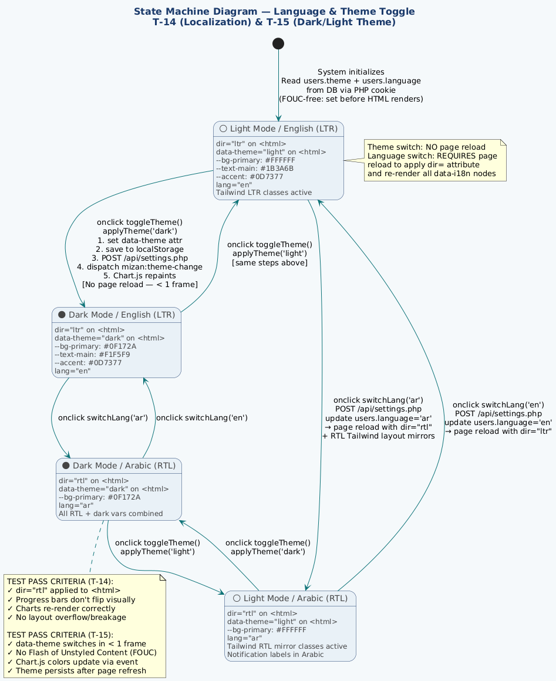
Figure 3State Machine: Language & Theme Toggle (T-14 & T-15)

2.5 Operator Procedures
The following explains the tests for processes necessary for operating the application in its production/live environment (cPanel/Hostinger).
- Deployment Process Testing: Tests for testing all steps required in deploying from the local development environment (XAMPP) to the live environment, including checking the deployment process for SSL/HTTPS enforcement and correct domain mapping.
- Admin Operations: Testing the functionality of the Administrator in viewing performance metrics of the entire application, as well as managing user accounts and posting announcements through the dashboard.php.
- Help Desk / Support Process Testing: Tests for testing all processes involved in the ticketing system (support.php and support.php API).

FEATURES TO BE TESTED
The following features are derived directly from the Mizan SRS v2.0 and SDS v2.0. Each feature is assigned a test identifier for traceability.
Table 2 FEATURES TO BE TESTED
Test ID | SRS Req. | Feature Description | Testing Type
T-01 | FR-01 | User Registration (bcrypt hash, email uniqueness) | Functional, Security
T-02 | FR-01 | User Login — valid credentials, session creation | Functional
T-03 | FR-01 | Brute-Force Protection — login_attempts rate limiter | Security
T-04 | FR-02 | Password Reset — CSPRNG token, SMTP email, expiry | Functional, Security
T-05 | FR-03 | Create / Edit / Delete Projects with ownership check | Functional
T-06 | FR-04 | Project Classification: Personal vs. Commercial (nature ENUM) | Functional
T-07 | FR-05 | Record Expense — DECIMAL(12,2) precision, category & vendor | Functional, Data Integrity
T-08 | FR-06 | File Upload — Vault (max 500 MB, MIME validation via finfo) | Functional, Security
T-09 | FR-07 | Warranty Expiry Notifications — 30-day scan, 24-hr deduplication | Functional
T-10 | FR-08 | Budget Overrun Notification — check_budget() trigger on INSERT | Functional
T-11 | FR-09 | Visual Reports — Chart.js bar, doughnut, P&L line chart | Functional, UI
T-12 | FR-10 | Export Reports as CSV (server-side) and PDF (browser print) | Functional
T-13 | FR-11 | Project Share Link — CSPRNG token, 30-day expiry, read-only view | Functional, Security
T-14 | FR-12 | Language Toggle — Arabic (RTL) / English (LTR) switch | Functional, UI
T-15 | FR-13 | Dark/Light Theme — CSS custom properties, no page reload (FOUC-free) | Functional, UI
T-16 | FR-14 | Dashboard Summary Metrics — aggregate SQL, Chart.js 6-month graph | Functional, Data Integrity
T-17 | NFR-01 | CSRF Protection — hash_equals() token validation on all POST endpoints | Security
T-18 | NFR-02 | SQL Injection Prevention — PDO prepared statements, 100% coverage | Security
T-19 | NFR-03 | Server-side XSS Prevention — htmlspecialchars() on all output | Security
T-20 | NFR-04 | Client-side XSS Prevention — innerHTML ban (textContent / createElement) | Security, Code Review
T-21 | NFR-05 | Session Timeout — idle session termination after 900 seconds (15 min) | Security
T-22 | NFR-06 | WCAG 2.1 AA Accessibility — aria-labels, focus rings, keyboard navigation | Accessibility
T-23 | NFR-07 | CSPRNG Token Entropy — random_bytes(32) for share tokens and password resets | Security
T-24 | NFR-08 | 60 FPS Performance Budget — rafThrottle / requestAnimationFrame enforcement | Performance
T-25 | SDS 5.3 | Admin Module — Separate login gate, RBAC is_admin flag, ticket management | Functional, Security
T-26 | SDS 5.3 | Notification Polling — Unread badge updated every 60 seconds | Functional, Performance
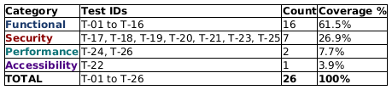
Figure 4 DIAGRAM B: TB_TestCoverage
Summary of test coverage by category — gives the reader a quick statistical overview ofthe 26 test cases.

4.FEATURES NOT TO BE TESTED
The following features and test categories are explicitly excluded from this Software Test Plan. Each exclusion is justified by academic scope limitations, infrastructure constraints, or the existence of a higher-trust authority (library vendor, hosting provider) who assumes responsibility for that component.
Table 3: FEATURES NOT TO BE TESTED
# | Feature / Scope | Category | Reason for Exclusion
1 | PHP Unit Testing of individual internal functions | White-Box Unit | Performed informally by each developer during Sprint coding phase; not within the scope of a formal STP
2 | Load / Stress Testing (concurrent users) | Performance | Mizan is an academic single-user application; stress infrastructure and load-generation tools are outside project budget
3 | Automated browser scripting (Selenium / Playwright) | Automation | Outside academic timeline and budget constraints; manual browser sessions are sufficient for the project scale
4 | Third-party library internals (Chart.js, SweetAlert2, PHPMailer) | Integration | Mature, versioned open-source libraries; internal correctness assumed per each library's official documentation
5 | Multi-user concurrency and race conditions | Performance | Concurrent-user simulation infrastructure not available in the academic environment
6 | Email rendering across external clients (Gmail, Outlook, Apple Mail) | UI / Platform | Dependent on third-party email clients outside the system boundary; SMTP delivery is tested, rendering is not
7 | Mobile native app testing (iOS / Android) | Platform | Mizan is a responsive web application only; no native mobile app exists in scope
8 | Database query performance optimization | Performance | Not a system requirement; mizan_db operates within academic-scale data volumes only
9 | Formal penetration testing by external party | Security | Requires specialized tools and certified personnel beyond the academic project scope
10 | Hostinger automated backup scheduling | Infrastructure | This is a hosting provider service (cPanel), not application code; outside developer control

5. Approach
The tests shall be carried out by all three developers, and both black box functional testing and white box security constraint testing will be applied in the process. The tests shall be carried out within the localhost environment provided by the XAMPP software suite, with actual browser sessions conducted in the primary Chrome and secondary Firefox browsers.
In order to achieve comprehensive testing throughout all levels of testing (both Integration and System testing), test cases shall be created according to the requirements of the Mizan SRS v2.0 and SDS v2.0 documents. Requirements traceability will be achieved in terms of mapping every test case to the corresponding Functional (FR) and/or Non-Functional Requirement (NFR).
Inputs/Outputs: Test Inputs: manual input of user data in the UI, mock data in SQL and file upload (testing the 500MB file vault limit). Test Outputs: JSON response data of the API, SweetAlert2 notifications in the UI, database state change in MySQL.
Criteria of Evaluation/Completion: Every test case, during the execution process, will register: preconditions, test input data, execution procedure, expected outcome, actual outcome and whether it is a success or failure. When the following criteria are met, the test process will be considered a success.
- 100% of all test cases are completed.
- All core requirements have passed their tests
- Several key NFRs (e.g. 2 seconds maximum for a query response time) are empirically proved

5.1 Component Testing
Component testing refers to verifying the functionality and behavior of individual software components prior to integrating them into the larger software solution. In the context of the Mizan application, which employs a loosely-coupled MVC architecture, the component testing procedure will only apply to boundary APIs and isolated front-end utility scripts since the in-depth internal PHP unit testing was done informally
1. Back-end API Component Testing: Individual PHP endpoints within the api/ folder (e.g., api/upload.php, api/expenses.php, and api/reports.php) will undergo individual testing away from the HTML/UI interface layer.
- Methodology: Tools such as Postman will be used to issue bare HTTP requests (GET, POST, PUT, and DELETE) to the targeted endpoint.
- Evaluation Criteria: The endpoint can be deemed successfully tested if it accepts the request input correctly (within its boundary conditions such as 500 MB file limit) and produces the right JSON data output, appropriate HTTP response code (e.g., 200 OK, 400 Bad Request, 403 Forbidden) and internal security checks such as the CSRF token.
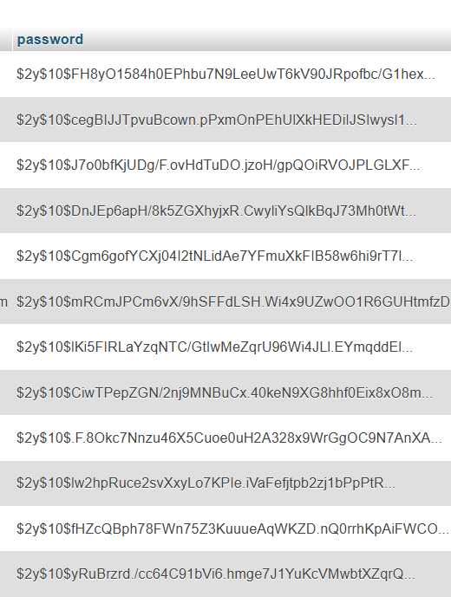
Figure 5:T-01 User Registration (bcrypt hash, email uniqueness)

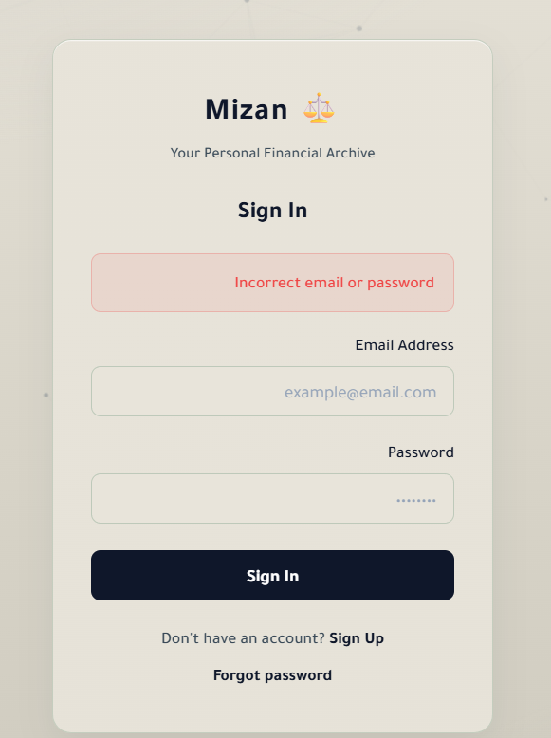
Figure 6:T-02-FR-01-User Login — valid credentials, session creation Functional
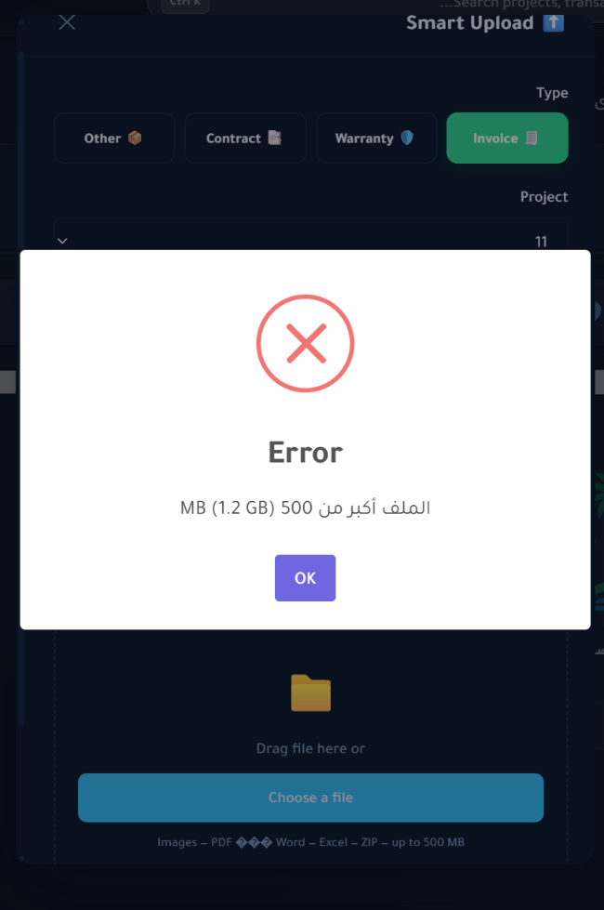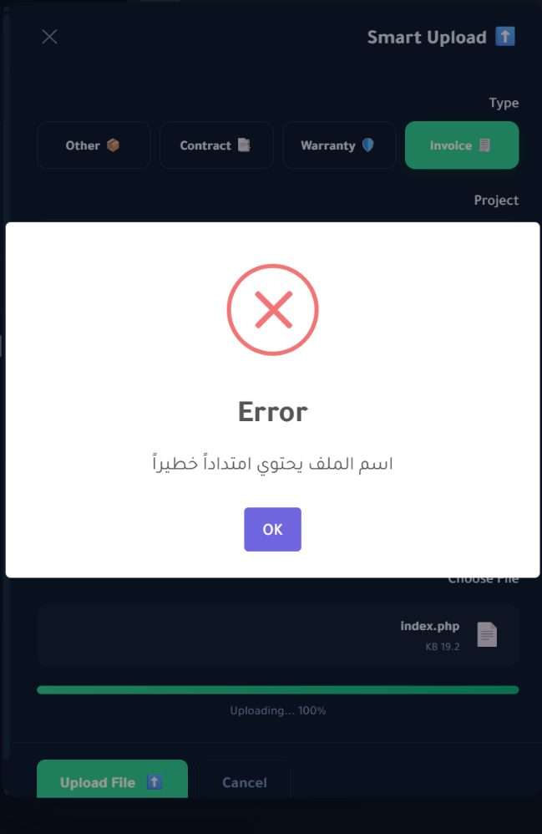
Figure 7:T-08-FR-06-File Upload — Vault (max 500 MB, MIME validation via finfo)Functional, Security

2. Front-end Utility Component Testing: The test will apply to isolated Vanilla JavaScript components that perform localized computations without external dependency.
- Methodology: Isolated JavaScript components such as assets/js/utils/math.js (used for expense calculations) and the isolated logic within includes/smart_upload_modal.php will undergo independent testing through browser developer console inputs.
- Criteria: The individual components should return mathematically correct computations and data formatting (for example when NaN, null values or extreme numbers are provided) prior to DOM manipulation.
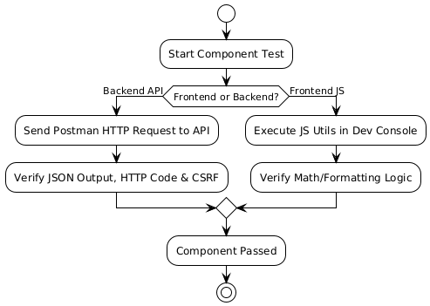
Figure 8:Component Testing (5.1)
Description: This diagram illustrates the isolated testing workflow, showing the split paths for testing Backend API endpoints (via Postman) and Frontend JavaScript utilities (via Developer Console) before integration.

5.2 Integration Testing
In the Mizan project, integration testing intends to confirm that different architectural layers, namely the Vanilla JavaScript client-side frontend, the PHP RESTful APIs server-side backend, and the MySQL 8.x RDBMS, work seamlessly together as a cohesive unit. Since this stage also includes System Testing, it will confirm that the software product as a whole meets all operational needs described in the SRS document.

1. Architectural Integration:
The test will check the unbroken data stream and security synchronization within the 3-tier MVC architecture. It will confirm that:
- The custom mizanFetch() JavaScript function properly issues asynchronous API calls and processes both expected and unexpected JSON API responses.
- The internal security framework (Double-Submit Guard for CSRF) works properly by synchronizing the front-end web browser session and the back-end PHP API validation.
- Any change in database state in MySQL is instantly reflected on the UI level without any manual refresh.

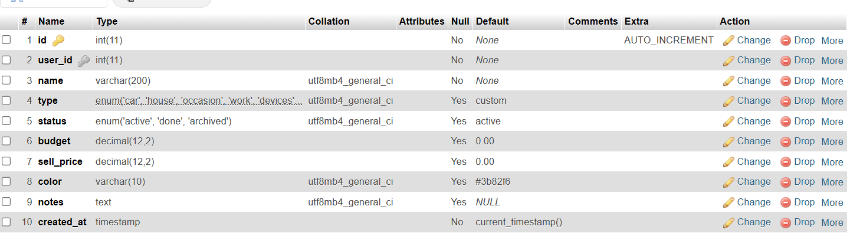
Figure 9:T-07-FR-05-Record Expense — DECIMAL(12,2) precision, category & vendor Functional, Data Integrity
2. Functionality and System Validation:
Within the full system evaluation process, all functional requirements (FR-01 to FR-14) will be tested through end-to-end web browser test scenarios running on the localhost XAMPP stack.

- The test data (mocked expense entries, vault files) will be prepared separately for each individual scenario to prevent any cross-influence between tests.
- The UI components such as SweetAlert2 confirmations, Chart.js visualizations, and Arabic/English bidirectional switching are included within the functional requirements testing scope.
- The system will prove its capabilities in achieving its operational goals by completing entire task workflows like linking an invoice to the expense and producing live summaries.
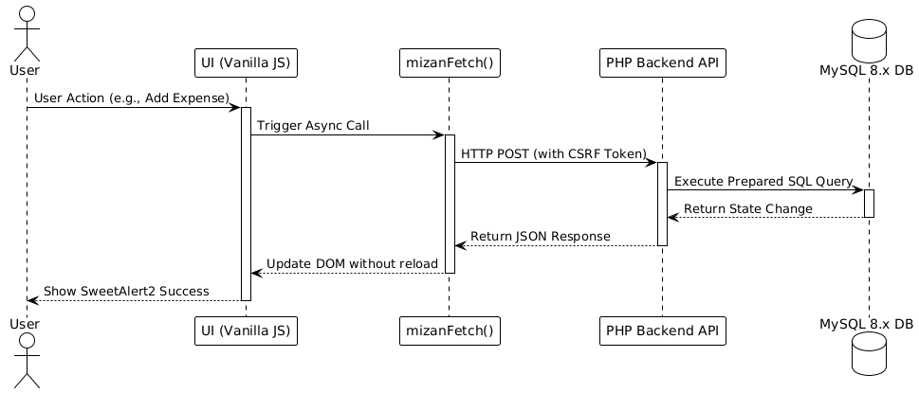
Figure 10Integration Testing (5.2)
Diagram Type: Sequence Diagram
Description: This diagram maps the step-by-step data flow across the 3-tier MVC architecture. It shows how user actions in the UI trigger mizanFetch() calls, which communicate with the PHP backend and update the MySQL database in a seamless cycle.

5.3 Conversion Testing
Conversion testing is done to make sure that all data elements have been converted from the old system into the new system format.
- Status: Not Applicable (N/A). Reason: The Mizan Personal Financial Management System is a greenfield project since it was developed from scratch. There is no existing system or any existing database from which the data needs to be migrated. Thus, the conversion testing has been excluded from this test plan.

5.4 Job Stream Testing
Testing of the job streams helps in ensuring that the Mizan app performs flawlessly in its desired live production environment, as opposed to the local environment used in the XAMPP setup. In this stage, verification of the server, live database performance, and background process automation shall be performed.

- Validation of Production Environment: Tests will be conducted on the live Hostinger cloud environment (through cPanel). It will ensure that SSL/HTTPS certificates are fully adhered to, routing paths work perfectly on a live Apache/LiteSpeed server, and the production environment variables are correctly set.

- Background Processes Automation (Cron Tasks): In the implementation of the Mizan app, various automated job streams have been employed in performing non-functional requirements.
- The aim of the test: is to ensure that the Hostinger Cron jobs correctly run the scan_user_warranties() and check_budget() PHP functions at the scheduled dates. These jobs should effectively detect the expiry of warranties and budgets, and then send notifications to the notifications table without human interference.

- Real-time Database and Concurrency: Verify that the live MySQL 8.x database can perform connection pooling and automated scheduled database backups without locking the database tables while users are using the system.

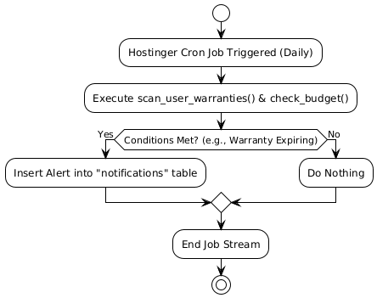
Figure 11: Job Stream Testing (5.4)

Diagram Type: Activity Diagram
Description: This diagram outlines the automated background processes (Cron Jobs) on the Hostinger server, showing how the system independently checks for budget limits and expiring warranties to generate automated notifications.

5.5 Interface Testing
Interface testing is conducted to guarantee that the Mizan system can efficiently communicate with all other systems and services external to its direct boundaries. Since Mizan functions securely as an independent web application, the testing process will only involve assessing the interactions of the system with necessary external server-side interfaces.
- SMTP Mail Server Interface: This test will assess whether Mizan successfully connects, authenticates, and sends out payload messages to the external SMTP server provided by Hostinger (using tools such as PHPMailer). This test will confirm whether outbound connection requests are not refused and whether the messages are correctly formulated for external mail clients.
- Web Server Operating System File System Interface: The Mizan system uses the operating system file system of the Hostinger server to store the 500 MB capacity "Vault." The interface test will determine whether the PHP back-end can communicate efficiently with the host's OS temporary directories, move uploaded files securely into permanent storage, and interact successfully with the host OS finfo library to read file header information.
- External API Isolation Check: Another important privacy and security aspect of the Mizan system is that it does not integrate with any external financial service APIs. In order to conduct interface testing, the system will be monitored using network traffic analysis from server logs to confirm that there are no outbound unauthorized calls to any external financial APIs.
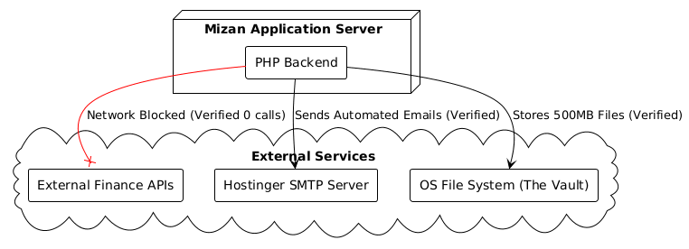
Figure 12Interface Testing (5.5)
Diagram Type: Component Diagram
Description: This visualizes the system's external boundaries. It clearly displays the authorized connections to the Hostinger SMTP server and OS File System (The Vault), while explicitly showing the blocked network paths to external financial APIs.
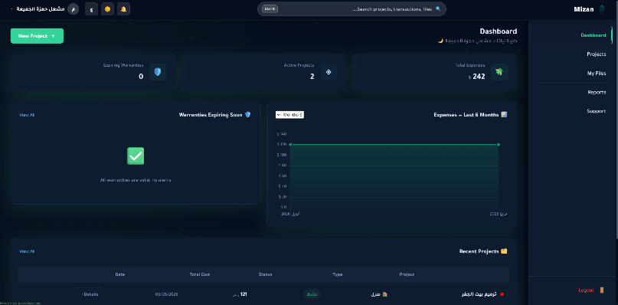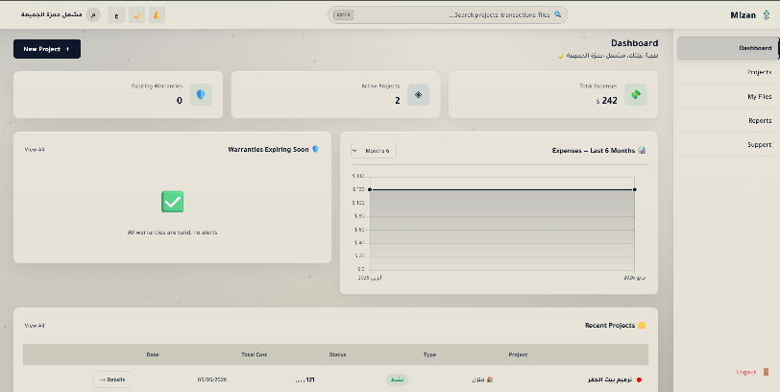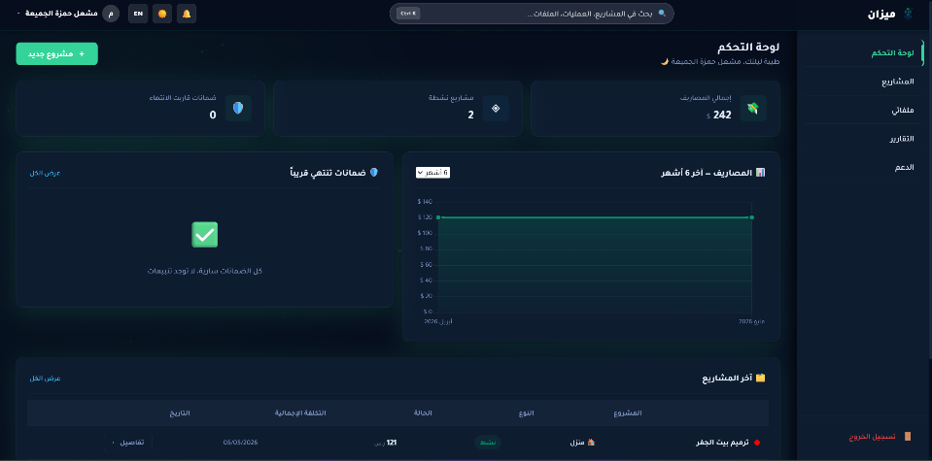
Figure 13:T-15-FR-13Dark/Light Theme — CSS custom properties, no page reload (FOUC-free)Functional, UI
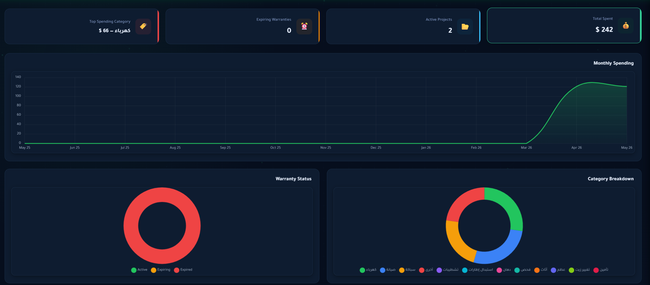
Figure 14:T-11 FR-09 Visual Reports — Chart.js bar, doughnut, P&L line chart Functional, UI

5.6 Security Testing
Following the template, security testing of Mizan would include checking for the effectiveness of controls used for internal access control mechanism and the auditability of operations performed.
- Access Control & RBAC (Controls): Testing would include verification of Role-Based Access Control (RBAC) using is_admin flag in the users table. This would involve logging into a standard account and trying to gain access to Admin Dashboard and the announcements management tool. Test would be successful if the system denies the request and redirects the user to the default standard dashboard with an "Unauthorized Access" message.
- Verification of Audit Trail (Auditability): All actions should leave a trail in the system so that one can prove that he did not alter any information. To achieve this, we would delete an expense, edit a project and change our password then check whether there is an entry in the activity_logs table for these actions indicating their user_id, action_type, ip_address and time. Further, we will confirm that these records are "append only" and cannot be manipulated or deleted by the user.
- Verification of Authentication Controls: Testing would include verifying brute force protection logic. For this, we will try five unsuccessful login attempts from one IP address. If the system locks out the IP for a defined period, test will be deemed successful by comparing the record against login_attempts table.
- Verification of Session Controls: This involves confirming that session timeout occurs after 15 minutes inactivity and session_regenerate_id(true) function is used.
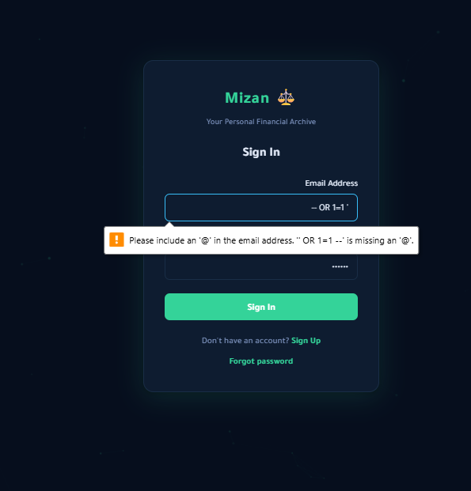
Figure 15:T-18-NFR-02SQL Injection Prevention — PDO prepared statements, 100% coverage Security
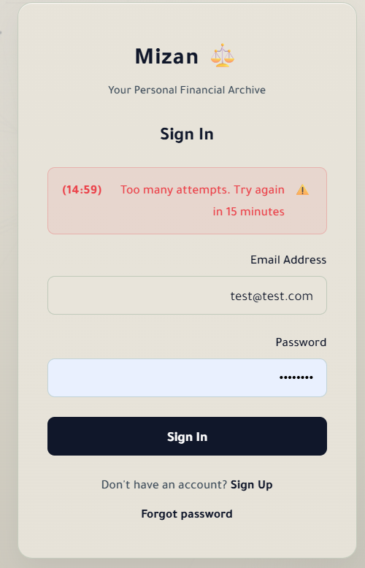
Figure :16T-03-FR-01 Brute-Force Protection — login_attempts rate limiter Security
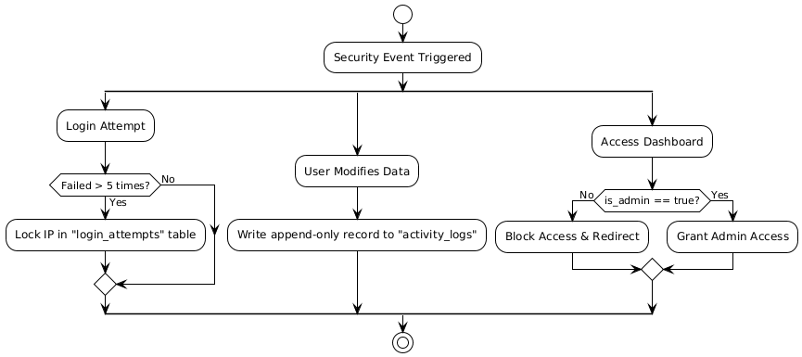
Figure 17: Security Testing (5.6)
Diagram Type: Activity Diagram
Description: This diagram details the logical workflows for internal controls and auditability. It shows the conditional branches for handling failed login attempts, writing append-only activity logs, and enforcing Role-Based Access Control (RBAC) for the Admin Dashboard

5.7 Recovery Testing
Recovery testing is carried out to confirm that Mizan can be restarted and data recovered in case of any failure or loss of integrity. This confirms the effectiveness of our data recovery capabilities.
- Database Restoration (MySQL): Here, we will create the worst-case scenario of a catastrophic database failure through the dropping of the mizan_db schema. The aim is to test whether it can be successfully recovered using the most recent .sql backup file, with all 14 tables and all of their Foreign Key relationships intact and no data losses. This test is considered successful when the application regains functionality.
- File System Recovery (The Vault): We will simulate the situation where there is no uploads/ directory. Testing will seek to confirm the success of recovering files from server backup copies to restore file assets. We shall check to see whether the restored file assets are consistent with those on record, that is, the file paths recorded in the files and invoices database tables.
- Session and State Recovery: Here, we will emulate the abrupt closure of the application due to the termination of sessions on the server side. Testing aims to verify whether the software will resume from the last state without leaving orphan files or broken database records behind and require user re-authentication.
- Automated Backup Verification: Verify that the backup schedule on the production server (Hostinger) is producing valid and not corrupted back-ups that can be retrieved and used on our local XAMPP environment if the need arises.
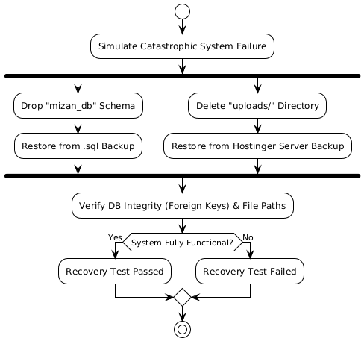
Figure 18: Recovery Testing (5.7)
Description: This diagram outlines the disaster recovery procedure. It simulates a catastrophic failure and shows the parallel processes of restoring the MySQL database from .sql backups and recovering Vault files from server backups

5.8 Performance Testing
The Mizan app's performance testing ensures that the application fulfills user expectations regarding speed, stability, and flexibility. This test includes the following pillars:
- Response Time: The application's capability of maintaining a 60 FPS rendering target will be checked using window.mzRafThrottle. In addition, we will ensure that all core API requests made by mizanFetch() return their results within 2.0 seconds, regardless of whether the request contains a sophisticated financial report or an extensive list of expenses.
- Availability: The availability of the application will be verified on the Hostinger production environment. In particular, we will make sure that the application can run successfully while performing other activities, such as continuously checking for notifications every 60 seconds while producing a PDF document.
- Portability: As part of the portability tests, the application will be evaluated in different environments. It should behave identically when running locally using the Windows XAMPP installation and when deployed to the Linux/Cloud production server. Moreover, we will check that the CSS layout and bi-directional (RTL/LTR) toggles work seamlessly in various web browsers (Chrome, Firefox, and Safari).
- Scalability: High-performance requirements include evaluating how the application behaves in cases where a single user account holds more than 1,000 expenses and 50 projects. The test passes when the charts on the dashboard and the "Vault" file listing do not suffer from reduced performance in terms of load speed and UI responsiveness.
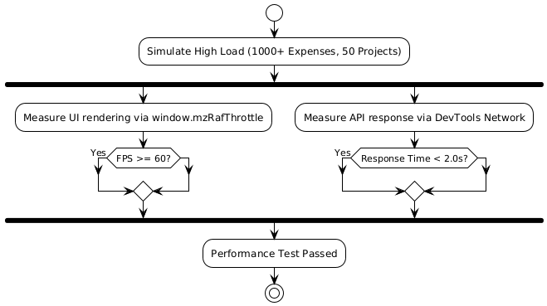
Figure 19: Performance Testing (5.8)
Diagram Type: Activity Diagram
Description: This diagram depicts the performance validation process under heavy load scenarios. It shows the parallel evaluation of the UI rendering speed (60 FPS) and the API response times (under 2.0 seconds).

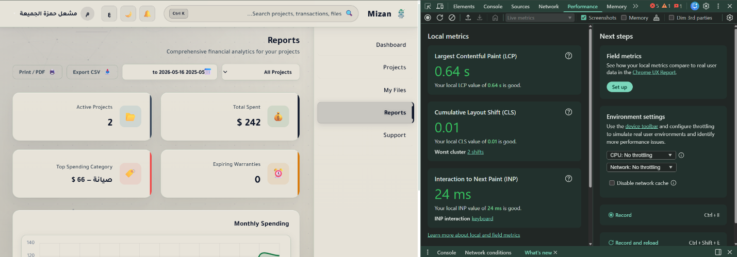
Figure 20:T-24-NFR-0860 FPS Performance Budget — rafThrottle / requestAnimationFrame enforcement Performance

5.9 Regression Testing
- The purpose of performing regression testing is to make sure that code changes, bug fixing, or an environmental update would not negatively affect the currently validated functionality within the application. This ensures stability of the software's 3-layer architecture.

- Re-validation of Core Modules: Every time there is a change made to the backend API files (api/*.php) or Security Layer (includes/security.php) a complete set of regression tests must be launched to check that a change to the "Vault" file uploading would not, for instance, inadvertently affect the logic behind "Expense" management or "Budget" notifications.
- Database Relationships Validation: As the number of "ON DELETE CASCADE" statements in all 14 database tables is high, it is important to test that an update of the Projects or Users table would not lead to deletion of information in the Warranties or Invoices databases, respectively.
- Standardized Baseline Testing: In order to avoid a situation when "data contamination" from unsuccessful previous tests may affect the current result, a standard baseline of running regression starts with re-installing the database from the authoritative database.sql file.
- User Interface/Experience: Besides functionality, regression testing includes checking that no changes in the UI/UX were accidentally introduced due to CSS changes of Dark/Light themes and RTL/LTR toggles.
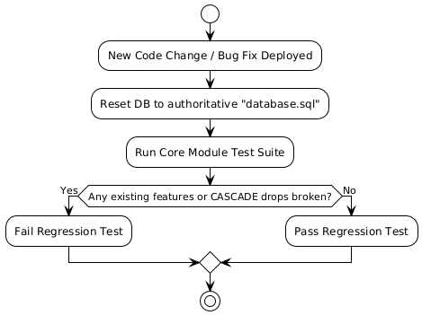
Figure 21: Regression Testing (5.9)
Diagram Type: Activity Diagram
Description: This diagram illustrates the safety-net workflow after a code change. It highlights the crucial step of resetting the database to the authoritative baseline before re-running core tests to prevent data contamination and ensure no existing features are broken.

5.10 Acceptance Testing
This is the last step in validating the Mizan system as a whole to assess its readiness for delivery based on all the requirements laid out earlier in this document.
- UAC Validation: A thorough walk-through of the application will be done to confirm that all functional requirements (FR-01-FR-14) are fully met. This will involve checking to see if the key functionalities such as expense tracking, vault file handling, and auto-generated warranty notifications are working as expected from the end-user's point of view.
- Functional Objective Validation: The output of the system (like the Chart.js graphs on the dashboard and the financial reports) will be evaluated for correctness. The acceptance test is dependent on the system being able to provide proper mathematical calculations and displaying real-time data integrity as required by the initial design objective.
- Delivery Package Validation: Before the final acceptance, the entire "Customer Package" will be assessed to make sure that all elements needed for deployment are included. These include:
- A complete directory of source code (Vanilla JS, PHP, and CSS).
- A .sql file containing the database scheme of 14 tables.
- The configuration files (for example, config/mail.php and security.php).
- Final End-to-End Test Scenario: A final test session will take place in the production environment (Hostinger). Completing a whole user cycle from registration, creating new projects, generating notifications, and logging out will be considered the final sign-off of the project's acceptance and submission.

5.11 Beta Testing
Testing will be carried out by a selected group of end-users (customers), using the pre-release version of the Mizan system to validate that the application meets the core business functional requirements (FR-01 to FR-14).
- Participants: The selected participants of the beta test group will include individuals outside the team (e.g., university students and freelancers) who belong to the target audience and have not been involved in the development process.
- Environment: The beta testing will be performed in the live environment of cloud hosting (Hostinger) to examine the system performance, responsiveness, and reliability in actual network conditions.
- Testing Activities: Participants will be required to carry out a full cycle of business processes including:

- Creation of a new project with a budget associated with it.
- Uploading documents into the "The Vault" and validating file correctness.
- Exporting financial reports.

- Validation & Feedback: Feedback and validation will be provided to the developers through the Support System or feedback forms regarding any issues, discrepancies in the interface/user experience or functional errors encountered. This feedback will be used to validate that the system can satisfy the users' financial management requirements.

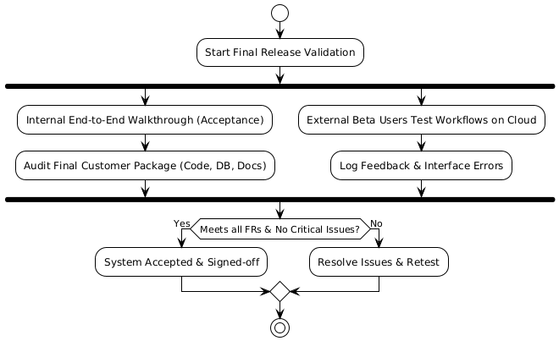
Figure 22Acceptance & Beta Testing (5.10&11)
Diagram Type: Activity Diagram /Flowchart
Description: This diagram maps the final release validation phase. It combines the internal end-to-end walkthroughs (Acceptance) and external user workflows on the cloud (Beta), culminating in the final project sign-off and delivery decision.

6. Pass / Fail Criteria
For a test case to be declared PASSED, it must meet the criteria where the actual outcome of the system precisely corresponds to the expected outcome specified by the Mizan SRS v2.0 and SDS v2.0 documents. On the other hand, for a test case to be declared FAILED, it should show:

Table 4PASS / FAIL Table
Category | Pass Criterion | Fail Condition
Functional | System produces the correct output, database state, HTTP status code, and JSON envelope for valid inputs. | Incorrect output, missing database update, missing field, or wrong HTTP status.
Security (CSRF) | All state-changing requests (POST/PUT/DELETE) without a valid token receive HTTP 403. No data is modified. | Any state-changing request without a token succeeds.
Security (SQLi) | All injection payloads are rejected. No SQL error or data leakage in response. Prepared statements (PDO) handle data securely. | Any query is modified by user input or database structure is exposed.
Security (XSS) | No injected script tag executes in any response. Output is safely escaped via htmlspecialchars() or DOM textContent. | Any script executes or unescaped HTML payload is rendered in the browser.
Security (File Upload) | Files with disallowed extensions or MIME mismatches are rejected. The 500 MB limit is strictly enforced. | Any dangerous file (e.g., .php disguised as .jpg) is accepted and executed, or limits are bypassed.
Performance | UI frame rate remains stable during Chart.js rendering and scrolling. Notification badge polls without locking the main thread. | Sustained frame drops, UI freezing, or notification polling causing severe network latency.
Accessibility & UI | Zero critical layout breaks when switching between Arabic (RTL) and English (LTR) modes or Light/Dark themes. | UI components overlap, become unreadable, or progress bars break during language/theme switching.
Data Integrity | Financial values are calculated and stored exactly as DECIMAL(12,2). CASCADE deletes successfully remove all associated child records (e.g., deleting a project deletes its expenses). | Any FLOAT rounding error is detected, or orphaned child records remain in the database.
Figure 23 DIAGRAM C: TB_DefectSeverity
Define the 4 defect severity levels with concrete Mizan examples, required actions, and time limits.

6.1 Suspension Criteria
The test process for a particular module and/or for the overall Mizan system will be immediately halted on account of the following criteria:
- Environment Issues: The local installation of Apache or MySQL crashes, the cloud hosting server goes down during deployment tests, and there are issues with database connectivity.
- Critical Defects: An important bug is found which prohibits running of any future test cases. This would include instances such as a repetition of the infinite redirect loop found within login.php or a complete breakdown of the session management process.
- Important Security Flaw: An exploitable security flaw is found in the system, thus enabling unauthenticated bypassing of the authentication module and granting regular users administrative privileges

6.2 Resumption Criteria
Testing can begin again once the following criteria have been satisfied:
- Defect Fix: The source of the code problem or server misconfiguration which caused the test to be suspended will be located and fixed and then pushed back to the GitHub repository's master branch.
- Environment Restore: The Apache server and mizan_db database will be confirmed working and available for testing.
- Regression Test: A limited regression test (smoke test) will be done on the fixed module to confirm that the fix was successful.
- Re-run Test Cases: All failed and terminated test cases will need to be run again from the start.

6.3 Approval Criteria
Testing Phase of Mizan SystemThe testing phase of Mizan system can be regarded as finished and approved provided that the following conditions are satisfied:
- 100% Functional Pass: RateAll the test cases related to the critical functionsof the core User Stories (Projects, Expenses, Vault, Reports) should pass successfully.
- Zero Critical/High DefectsThere are no pending defects related to the security of the system like XSS attack, SQL injection, CSRF attack and data integrity issues.
- Team Consensus: All three development team members (Mishal, - review the test logs and unanimously agree that the Potentially Shippable Product Increment (PSPI) meets the Definition of Done.
- Formal Acceptance: The final testing documentation (STS) and the live system deployment are submitted to and approved by the course instructor (Dr. Saqib Saeed) as per the academic grading rubric

7. Testing Process

7.1 Test Deliverables

7.1.1 Test Documentation

- Software Test Plan (STP): The existing STP document baseline is
- Test Case Specifications: A well-organized testing that aligns with the Requirements Traceability Matrix (RTM). It includes Test ID, System Requirements Specification (SRS) requirement, preconditions, test steps, expected results, actual results, and pass/fail decision.
- Test Execution Log: A chronological document of test execution, specifying the name of the tester, test date, test environment (Local XAMPP or Live Cloud), and test result.
- Test Incident Reports: Formal reports of bug defects, including Test ID, problem identification, severity (Critical, High, Medium, Low), reproducibility steps, and resolution status.

7.1.2 Test Data & Evidence
- UI Execution Evidence: Screenshots taken directly from the browser for all executed functional test cases to be included within the Test Case Specification spreadsheet.
- DevTools Profiling Screenshots: Screenshots using Chrome DevTools (Network for 60-second notification polling validation and Performance for frame rate analysis at 60 FPS).
- Accessibility Audit Results: Axe DevTools extension audit report exported either as HTML or PDF files, proving that the website satisfies the requirements of WCAG 2.1 level AA on both Light and Dark theme pages.
- Database Validation Results: Query results exported either as CSV or phpMyAdmin screenshot proving successful completion of database data integrity tests (such as DECIMAL(12, 2) type and successful CASCADE delete operation).
- The PSPI (Potentially Shippable Product Increment): The final tested and stabilized Mizan web application deployed into live Hostinger cloud server environment as well as code base uploaded to GitHub.

7.2 Testing Tasks
Table 5:Testing Tasks
# | Task | Predecessor | Assignee | Target Date | Effort (hrs)
2 | Prepare Test Case Specifications (all 26 test cases) | Task 1 | All Members | 09/05/2026 | 6
3 | Initialize test environment (XAMPP reset, mizan_db init) | Task 1 | - | 09/05/2026 | 1
4 | Execute Core Functional Tests (T-01 to T-13, T-16) | Tasks 2, 3 | - | 10/05/2026 | 5
5 | Execute Security Tests (T-17 to T-21, T-23) | Tasks 2, 3 | - | 10/05/2026 | 4
6 | Execute Performance Tests (T-24, T-26) | Task 3 | Mishal Al-jumaih | 11/05/2026 | 2
7 | Execute Accessibility Tests (T-22) | Task 3 | - | 11/05/2026 | 2
8 | Execute Data Integrity Tests (T-07, T-09, T-10 verification) | Task 3 | - | 11/05/2026 | 2
9 | Execute Localization & Theme Tests (T-14, T-15) | Task 4 | Mishal Al-jumaih | 11/05/2026 | 1
10 | Execute Admin Module Tests (T-25) | Task 4 | Mishal Al-jumaih | 11/05/2026 | 2
11 | File Test Incident Reports for all failures | Tasks 4-10 | All Members | 12/05/2026 | 2
12 | Developer fixes for all Critical/High severity defects | Task 11 | All Members | 13/05/2026 | 4
13 | Regression Test Run (re-run all failed T-IDs) | Task 12 | Non-fixing member | 13/05/2026 | 2
14 | Write Test Summary Report | Task 13 | Mishal Al-jumaih | 14/05/2026 | 2
15 | Deliver all test documentation, evidence, and PSPI | Task 14 | All Members | 14/05/2026 | 1

7.3 Responsibilities
The testing process for the Mizan system is entirely managed and executed internally by the core project team.
To ensure a thorough validation process and separation of duties during regression, responsibilities are delegated as follows:
- Test Lead & Management (Mishal Al-jumaih): Responsible for designing the overall Software Test Plan, coordinating the testing schedule, and managing test activities. Executes specific Non-Functional tests (Performance, Localization) and Admin Module tests. Resolves managerial impediments and authorizes the final Test Summary Report.
- UI/UX & Accessibility Tester (-): Responsible for executing all core Frontend Functional tests (T-01 to T-13, T-16) and evaluating the interface using accessibility audit tools. Responsible for witnessing UI anomalies, checking cross-browser compatibility, and resolving frontend design defects.
- Backend, Security & DB Tester (-): Responsible for preparing the local sandbox environment (mizan_db and XAMPP configurations). Executes Grey/White-Box testing, including API Security tests (T-17 to T-23) and Data Integrity checks. Responsible for resolving complex backend logic, SQL queries, and server-side vulnerabilities.
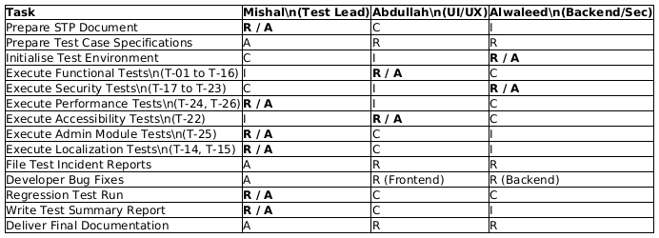
Figure 24 DIAGRAM D: TB_RACI
RACI matrix mapping each testing task to the three team members. Clarifies accountability and avoids overlap. R=Responsible A=Accountable C=Consulted I=Informed

7.4 Resources
The following resources are allocated to ensure the successful performance of all scheduled testing tasks for the Mizan project:

7.4.1 Human Resources
- Three (3) dedicated software engineering students allocating a combined total of 40 hours exclusively for test preparation, execution, and defect resolution over the 7-day testing period.

7.4.2 Hardware Resources
- Developer Workstations: Standard laptops running Windows 10/11 or macOS with a minimum of 8 GB RAM, allocated for local XAMPP hosting and intensive browser profiling.
- Mobile Testing Device: A Huawei Tablet (allocated within the project budget) utilized specifically for validating responsive UI layouts, touch interactions, and mobile viewport adaptations.

7.4.3 Software & Environment Resources
- Local Sandbox: XAMPP stack (Apache 2.4, PHP 8.x, MySQL 8.x) configured with strict php.ini directives (e.g., 500MB upload limits) to mirror the production environment.
- Cloud Production Environment (UAT): Hostinger cPanel shared hosting with a live domain, active SSL certificate, and SMTP mail configuration for final User Acceptance Testing.

7.4.4 Automated and Diagnostic Testing Tools
- axe DevTools (Browser Extension): Sourced from Deque Systems; utilized for automated WCAG 2.1 Level AA accessibility auditing across all interface views.
- Chrome DevTools: Built-in browser diagnostics utilized for automated network monitoring (polling intervals) and visual frame rate analysis (rafThrottle performance profiling).
- Postman / cURL: API testing clients utilized for crafting malformed HTTP requests and automating backend endpoint security evaluations independent of the frontend UI.
- phpMyAdmin: Integrated database management tool utilized for rapid querying and manual validation of database states following CRUD operations.

7.5 Schedule
The testing schedule below is strictly aligned with the Mizan SPMP v2.0 project timeline. Hardware, software, and test tools will be allocated and available from 08/05/2026 through 14/05/2026.
Table 6:Schedule
Date | Activity | Duration | Milestone
08/05/2026 | Finalize and submit Test Plan (STP) document | 1 day | STP v1.0 complete
09/05/2026 | Prepare Test Case Specifications; initialize test environment | 1 day | Test Cases ready
10/05/2026 | Execute Functional Tests (T-01 to T-16) & Security Tests (T-17 to T-23) | 1 day | Functional & Security executed
11/05/2026 | Execute Performance, Accessibility, Data Integrity, Localization, and Admin tests | 1 day | All 26 test cases executed
12/05/2026 | File Test Incident Reports; prioritize defects by severity | 0.5 day | Incident Reports filed
13/05/2026 | Developer bug fixes; Regression test run | 1 day | All critical defects resolved
16/05/2026 | Write Test Summary Report; deliver all test documentation and evidence | 0.5 day | Final testing phase complete

8.Environmental Requirements

This section outlines the environmental attributes of the testing environment required for validating the Mizan system.

8.1 Hardware
The following set of hardware resources are needed to accomplish the testing activities: Developer Workstations: Laptops/PCs equipped with at least 8GB RAM for the local Apache server and MySQL database. Testing Devices: Desktop monitors for testing dashboard UI and mobile devices (in-browser emulation) for CSS responsiveness testing.

8.2 Software
For testing, the following set of software is required: Server Environment: XAMPP with Apache, MySQL 8.x and PHP 8.x. Browsers: Latest versions of Google Chrome, Mozilla Firefox and Microsoft Edge. Operating Systems: Windows 10/11 for local development, Cloud Linux for live UAT deployment.

8.3 Security
Data protection and environment security measures will be taken: Data Isolation: Tests are conducted on an isolated database (mizan_db), preventing any data loss in other systems. Access Control: System authentication should always be turned on and require valid login credentials and CSRF token to be present in state-altering tests. Encryption: Verifying SSL/HTTPS configuration in the live cloud server.

8.4 Tools
The following tools and methodologies are employed in the testing efforts: Postman: Used for functional API testing of modules like api/expenses.php and api/projects.php. Chrome DevTools: Utilized for debugging JS logic in assets/js/main.js and monitoring the 60 FPS performance target. axe DevTools: Employed for automated accessibility auditing to ensure WCAG 2.1 compliance. PHPMailer: Integrated within config/mail.php to test the password reset and SMTP notification workflows.

8.5 Publications
The following documents support the testing activities: Mizan SRS v2.0: Baseline for functional and non-functional requirements. Mizan SDS v2.0: Blueprint for system components and database design. database.sql: The authoritative source for schema and relational integrity constraints.

8.6 Risks and Assumptions
Significant constraints and risks associated with testing tasks include: Risk: Incompatibility between local XAMPP settings and live cloud hosting PHP configurations. Contingency: Use the config/.env file to manage environment-specific variables and perform early staging deployments. Assumption: The local test machine has sufficient resources to run the MySQL 8.x engine without significant latency. Constraint: SMTP testing depends on active internet connectivity and correct port configurations in mail.php.
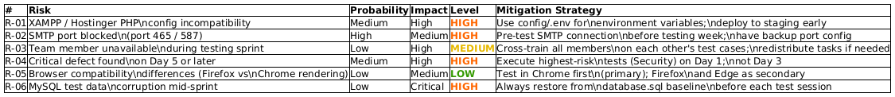
Figure 25 DIAGRAM F: TB_RiskMatrix
Classify each identified testing risk by probability and impact level with mitigationstrategy.
Color coding: 🔴 High 🟡 Medium 🟢 Low

9. Change Management Procedures
The Mizan project follows an Agile (Scrum) methodology, and the change management process for this Software Test Plan is designed to be iterative and collaborative:
- Change Initiation: Any member of the testing team can initiate changes to the test plan due to evolving technical needs and implementation challenges during Sprints.
- Change Evaluation: The suggested changes are evaluated within the daily meeting of the team known as the "Daily Scrum" or "Sprint Review". The entire team evaluates the effect of change on the total scope of tests and system requirements.
- Change Authorization: Change is made by mutual agreement of the team. Upon approval by the team itself acting as Change Control Board, the Test Lead (Mishal Al-jumaih) will make an update to the version number and revision history.
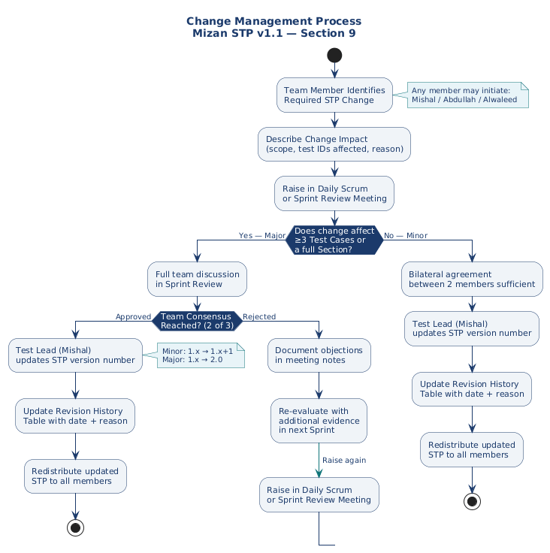
Figure 26 DIAGRAM G: FC_ChangeManagement
Visualise the Agile change management workflowfor this STP — from initiation through DailyScrum review to Test Lead authorization.

10. Test Approvals
The following signatures indicate formal approval of this Software Test and confirm that the testing aligns with the project’s quality standards:
Name | Role
Mishal Al-jumaih | Scrum Master & Test Lead
- | UI/UX Lead & Developer
- | Lead Programmer & DB Admin

